实验内容：

1、创建和增加节点 的方法

createElement（）：创建节点

appendChild（）：末尾追加方式插入节点

insertBefore（）：在指定节点前插入新节点

cloneNode（）：克隆节点

完成如下的界面，并完成按钮的功能

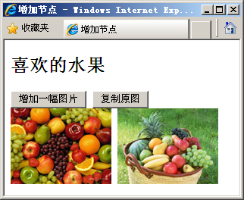

截图：

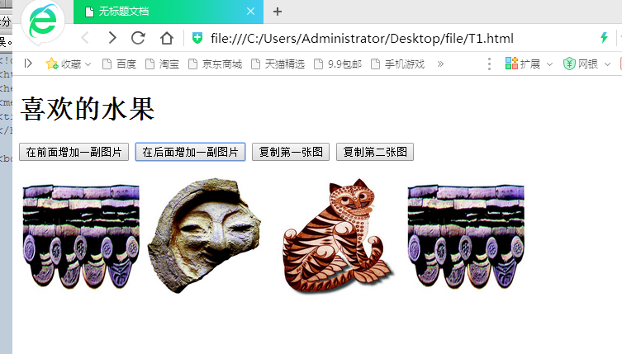

代码：

<!doctype html>

<html>

<head>

<meta charset="utf-8">

<title>无标题文档</title>

</head>

<body>

<h1>喜欢的水果</h1>

<p><input type="button" value="在前面增加一副图片" onclick="beforeappend()"/>

<input type="button" value="在后面增加一副图片" onclick="afterappend()"/>

<input type="button" value="复制第一张图" onclick="copyNewImg(1)"/>

<input type="button" value="复制第二张图" onclick="copyNewImg(2)"/>

</p>

<img src="1.jpg" width = "150" height="150" name = "1" id ="img1">

<img src="2.jpg" width = "150" height="150" id ="img2">

<script>

var imgs;

function copyNewImg(tag){

var ids = "img"+tag

imgs = document.getElementById(ids).cloneNode(false);

document.body.appendChild(imgs);

}

function newImg(){

imgs = document.createElement("img");

imgs.setAttribute("src","3.jpg");

imgs.setAttribute("width","150");

imgs.setAttribute("height","150")

}

function afterappend(){

newImg();

document.body.appendChild(imgs);

}

function beforeappend(){

var oldnode = document.getElementById("img1")

newImg();

// oldnode.parentNode = document

oldnode.parentNode.insertBefore(imgs,oldnode);

}

</script>

</body>

</html>

2、删除节点

删除和替换节点的方法

removeChild（）：删除节点

replaceChild( ) ：替换节点

完成如下的界面，并完成按钮的功能

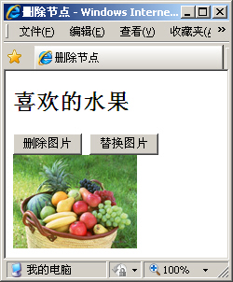

截图：

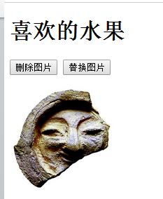

代码：

<!doctype html>

<html>

<head>

<meta charset="utf-8">

<title>无标题文档</title>

</head>

<body>

<h1>喜欢的水果</h1>

<p><input type="button" value="删除图片" onclick="deleteImg()"/>

<input type="button" value="替换图片" onclick="displayImg()"/>

</p>

<img src="1.jpg" width = "150" height="150" id ="img1">

<script>

var imgs;

function newImg(){

imgs = document.createElement("img");

imgs.setAttribute("src","3.jpg");

imgs.setAttribute("width","150");

imgs.setAttribute("height","150")

}

function deleteImg(){

var oldimg = document.getElementById("img1")

oldimg.parentNode.removeChild(oldimg);

}

function displayImg(){

var oldimg = document.getElementById("img1")

newImg();

oldimg.parentNode.replaceChild(imgs,oldimg);

}

</script>

</body>

</html>

3、表格的操作：完成如下的页面，并完成按钮的功能

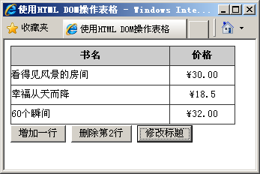

截图：

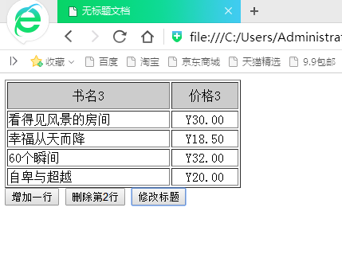

代码：

<!doctype html>

<html>

<head>

<meta charset="utf-8">

<title>无标题文档</title>

</head>

<body>

<table border="1" id="mytable">

<tr bgcolor="#CCCCCC">

<td width="200" height = "30" align="center">书名</td>

<td width="80" height = "30" align="center">价格</td>

</tr>

<tr>

<td>看得见风景的房间</td>

<td align="center">Y30.00</td>

</tr>

<tr>

<td>幸福从天而降</td>

<td align="center">Y18.50</td>

</tr>

<tr>

<td>60个瞬间</td>

<td align="center">Y32.00</td>

</tr>

</table>

<input type="button" value="增加一行" onclick="addOneRow()"/>

<input type="button" value="删除第2行" onclick="deleteSecondRow()"/>

<input type="button" value="修改标题" onclick="alterTitle()"/>

<script>

var tables = document.getElementById("mytable");

function addOneRow(){;

var newRow = tables.insertRow(tables.rows.length);

var cell1 = newRow.insertCell(0);

cell1.innerHTML = "自卑与超越";

var cell2 = newRow.insertCell(1);

cell2.innerHTML = "Y20.00";

cell2.align = "center";

}

function deleteSecondRow(){

tables.deleteRow(2);

}

var count = 1;

function alterTitle(){

var cellss = tables.rows[0].cells;

cellss[0].innerHTML = "书名"+count;

cellss[1].innerHTML = "价格"+count;

count++;

}

</script>

</body>

</html>

4.书上：P166 图7-16

截图：

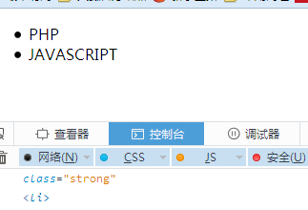

代码：

<!doctype html>

<html>

<head>

<meta charset="utf-8">

<title>无标题文档</title>

</head>

<body>

<ul>

<li>PHP</li>

<li>JAVASCRIPT</li>

<li class="strong">UI</li>

</ul>

<script>

var child = document.getElementsByTagName("li")[2];

var attr = child.getAttributeNode("class");

console.log(child.removeAttributeNode(attr));

console.log(child.parentNode.removeChild(child));

</script>

</body>

</html>